|  |
| --- |
| sharknado Games Inc. |
| **Shark Attack 3: In Space** |
| The sharks are back, but now in space |
| Version #1.0  All work Copyright © 2016 by Sharknado Games.  All rights reserved. |
| **Aaron Fernandes, Arlina Ramrattan, Neil Reading & Omid Khataee** |
|  |

|  |
| --- |
| 16-Aug-1 |

Contents

Version History 3

V0.1 3

V0.2 3

Design Analysis 4

Game Overview 4

Controls 4

Interface Sketch 4

Menu Screen 4

Instruction Screen 4

Playing Screen 5

End Screen 5

Game World 5

Levels 5

Level 1 5

Level 2 5

Level 3 5

Characters 5

Enemies 6

Weapons 6

Vehicles 6

Scoring 6

Level 1 6

Level 2 6

Level 3 6

Future Features 6

Game Link 6

# Version History

## V0.1

* added first level
* added readme.md
* added first level to ref.ts
* changed title
* remoted unneeded files
* bg asset
* made Scene an enum
* added levels 1,2, and 3
* fixed menu

## V0.2

* Added all references and links
* Added player for L1
* Added different treasure
* Added bullet class and functionality
* Added collisions between player and shark, player and heart, and bullet and shark
* Added functionality for level changing to L2
* Made and added new background
* Changed Background
* Changed player and bullet
* Added InjuredPeople class
* Changed treasure to injured people
* Added change level to level 3

# Design Analysis

## Game Overview

The Sharks have attack again, this time in space! Your goal as the player is to battle your way through the levels and destroy the Shark’s leader and army. Level 1 is where you will be battling the defence Sharks on your way to the ship. Level two starts when you get to the ship, now you have to find your way through the ship to where the Leader is. And then finally, level 3, is where you face the Shark Leader.

The player is a cop who believes the sharks are invading and no one believes him so he takes his trusty laser gun and fights them himself.

## Controls

Shark Attack 3 uses a mouse to direct whether the cop moves up or down. The cop cannot be moved left or right. The laser can be shot with clicking the left button on the mouse.

## Interface Sketch

### Menu Screen

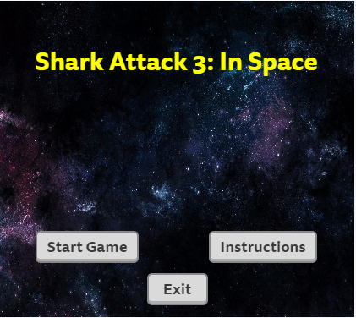

### Instruction Screen

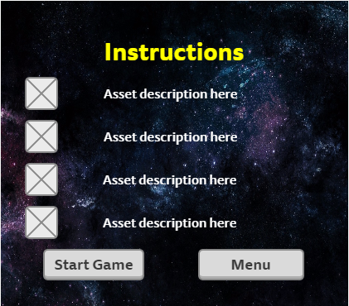

### Level 1

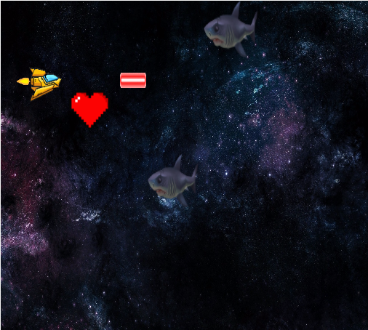

### Level 2

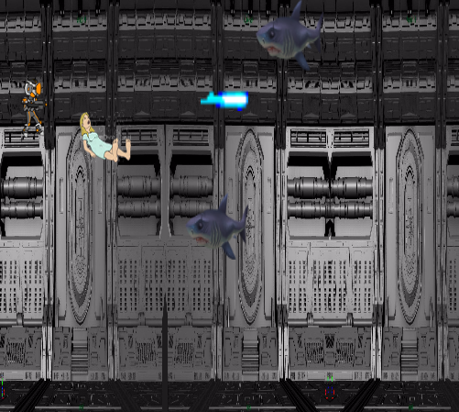

### Level 3

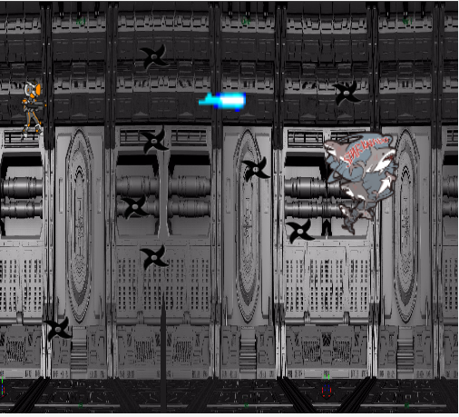

### Losing Screen

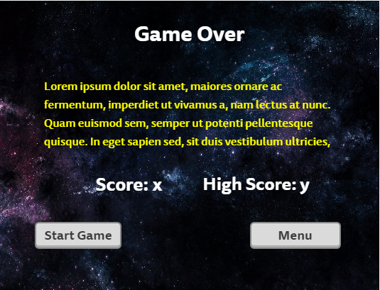

### Winning Screen

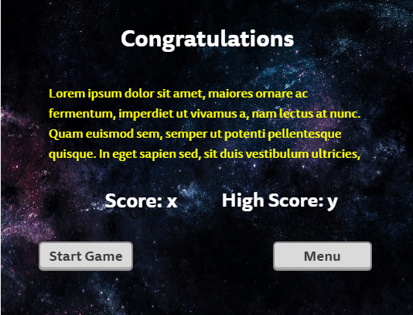

## Game World

The game is taking place in outer space just beyond the outskirts of our planet.

## Levels

### Level 1

The player just got out of the earths atmosphere and is facing the defenders of the Shark army. Goal: to reach the ship with minimal damage

### Level 2

The player has entered the ship and now has to fight the remaining forces while tying to get to the Shark Leader.

### Level 3

The player has made it to the Leader and now has to win against them.

## Characters

The avatar is a cop, trying to defend the earth from an invading Shark army.

## Enemies

The enemies in this game are sharks. They move right to left and sometimes drifts up or down. You lose lives if you get bitten.

## Weapons

The player will only have access to a laser gun, which can be shot with the left click of the mouse.

## Vehicles

The player will be in a spaceship but only for the first level.

## Scoring

### Level 1

To pass level 1 you need to kill 30 sharks, with each shark worth 10 points. The player has chances to regain lost lives by collecting a heart, but cannot exceed 10 lives.

### Level 2

To pass level 2 you need to save 10 people, with each save worth 10 points. The player can also kill sharks, each worth 10 points.

### Level 3

There is no scoring in level 3.

## Future Features

All functionality to be added later and maybe some bonus material

## Game Link

Microsoft Azure: <https://html5-arcade-game.azurewebsites.net/>